Organizational Element | Configured Value
Company Name | ABC Pvt. Ltd.
Company Code | ABC1 — ABC Pan India
Purchasing Organization | ABC1 — ABCJ Central Purchasing
Purchasing Group | ABC1 — Raw Materials Buyers
Plant | ABC01 — Delhi Manufacturing Plant
Storage Location | ABC01 — Main Warehouse, Delhi
Valuation Area | ABC01 (Plant-level valuation)
Fiscal Year Variant | ABC3 — April to March (Indian FY)
Table 1: Organizational Structure — ABC Pvt. Ltd.

Module | Full Name | Role in P2P
MM | Materials Management | Core module — manages vendor masters, material masters, purchase requisitions, purchase orders, goods receipts, and invoice verification. MM is where the entire procurement transaction originates and is controlled.
FI | Financial Accounting | Receives the financial impact of every procurement event. Goods Receipt posts a GR/IR clearing entry. Invoice Verification posts vendor liability. Payment Processing clears the open item and closes the payable.
Table 2: SAP Modules Used in the P2P Process

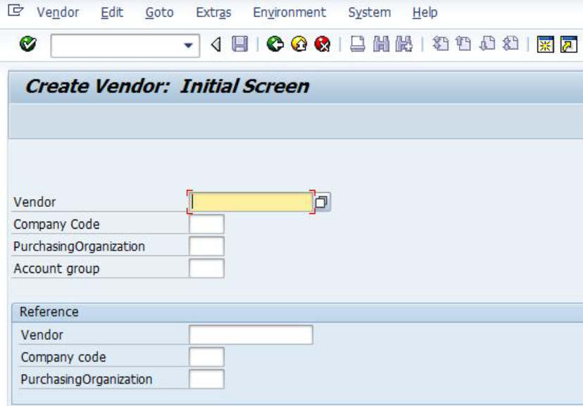
Figure 2.1: Vendor Master Creation Screen (XK01) showing initial setup and general data entry including vendor name, address, and organizational details

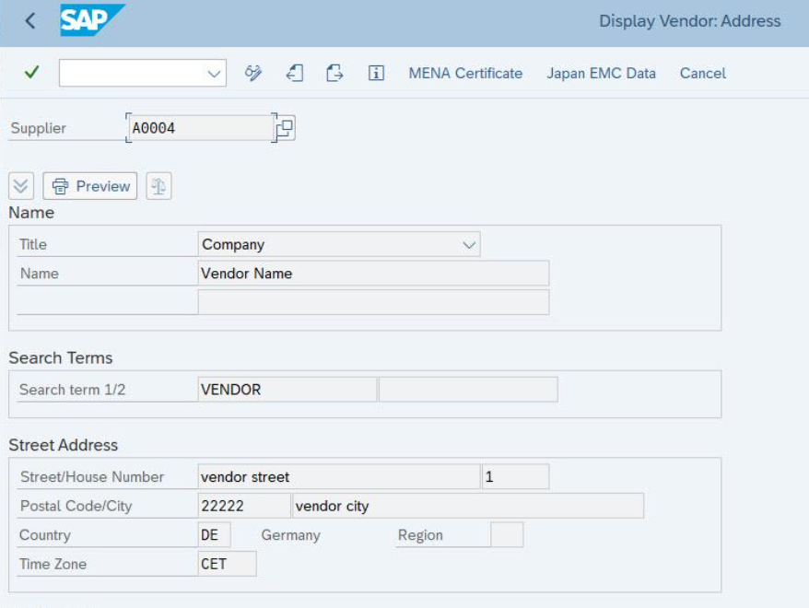
Figure 2.2: Vendor Master Creation Screen (XK01) displaying initial vendor setup and general data fields such as company name, address, and organizational information
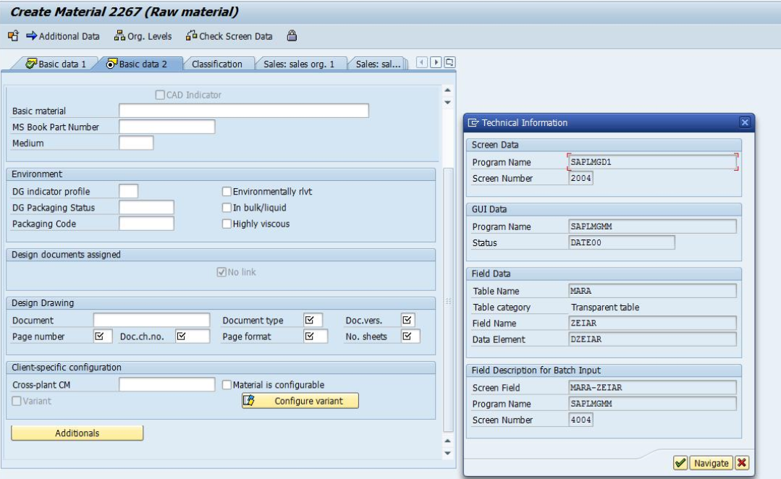
Figure 3: Material Master Screen (MM01) showing basic data, purchasing, and accounting views
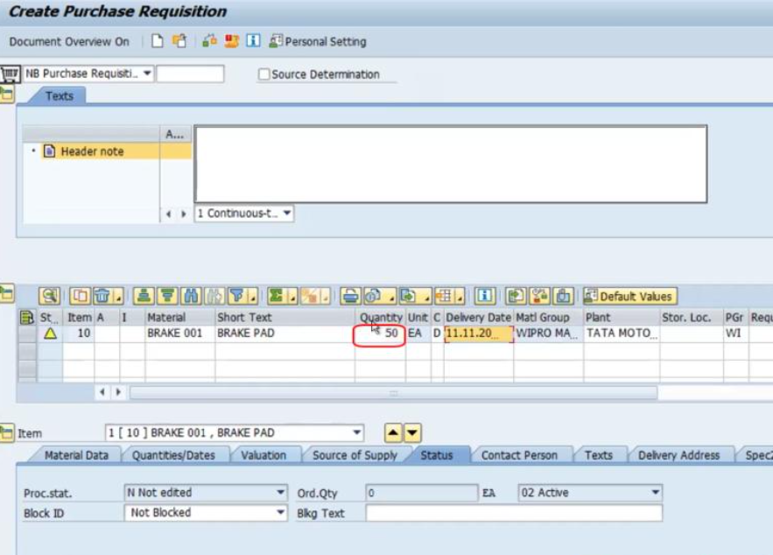
Figure 4: Purchase Requisition Screen (ME51N)

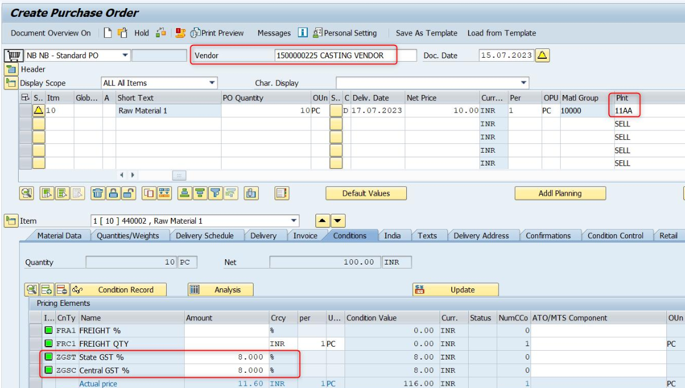
Figure 5: Purchase Order Screen (ME21N)

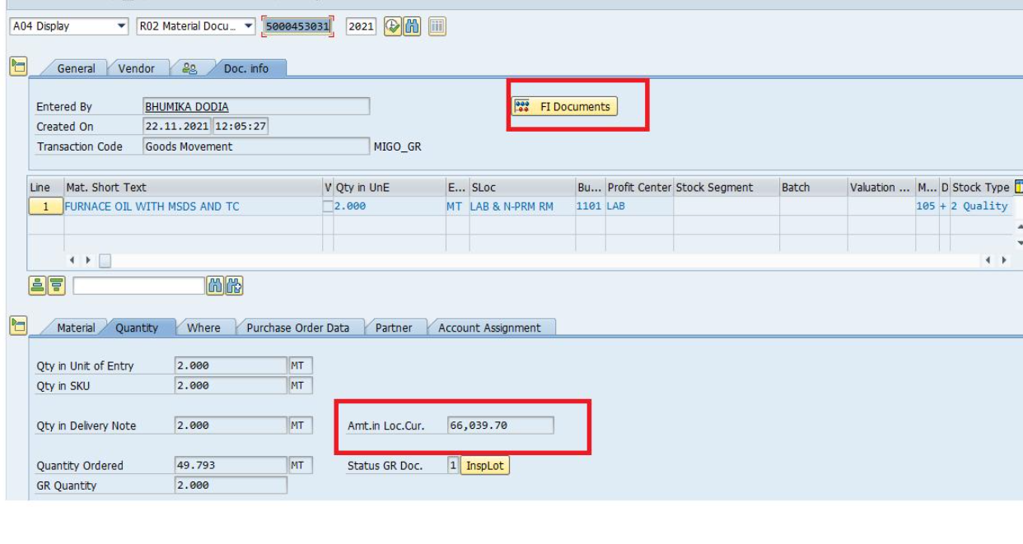 Figure 6: Goods Receipt Screen (MIGO)
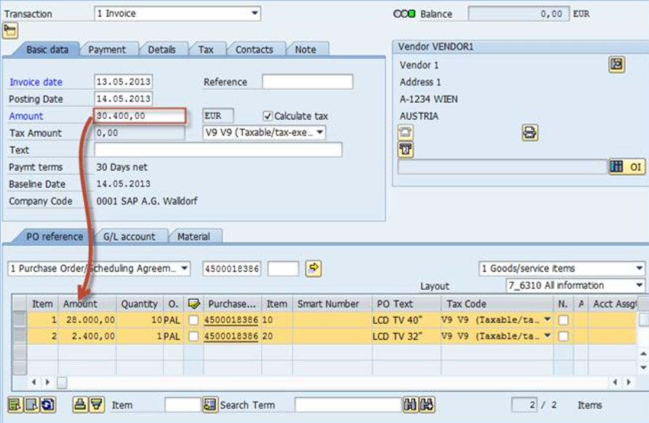
Figure 7: Invoice Verification Screen (MIRO)
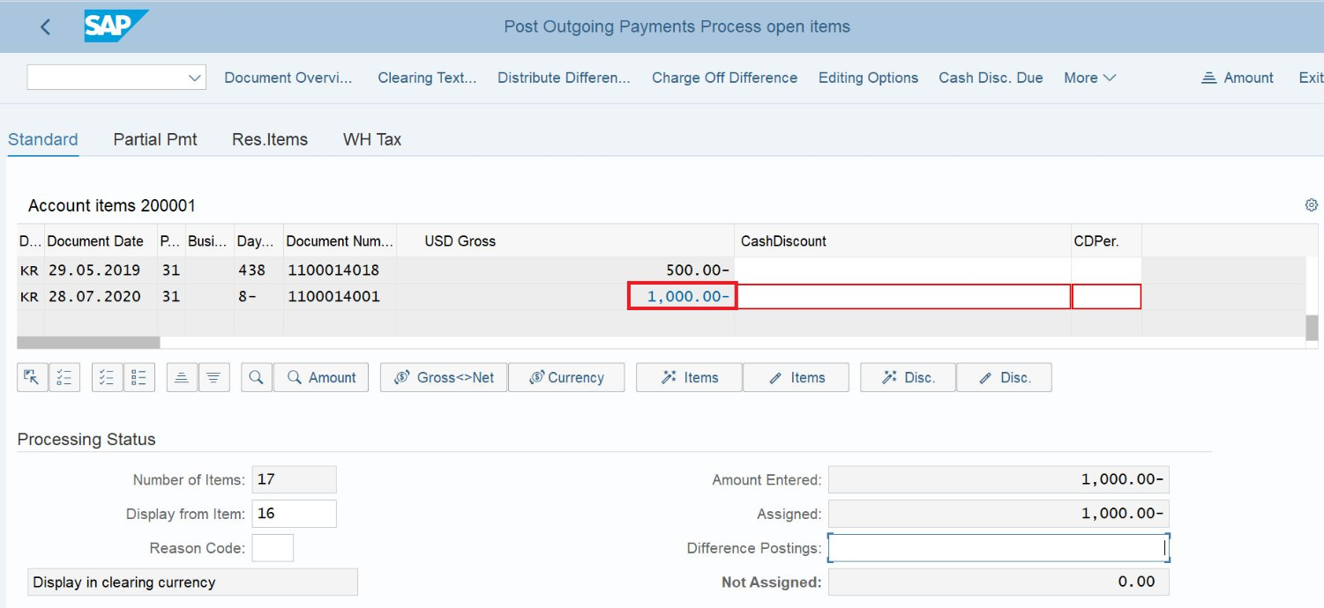
Figure 8: Payment Processing Screen (F-53)
7. Transaction Codes Summary

T-Code | Transaction Description | Module
XK01 | Create Vendor Master | MM / FI
XK02 | Change Vendor Master | MM / FI
MM01 | Create Material Master | MM
MM02 | Change Material Master | MM
ME51N | Create Purchase Requisition | MM
ME52N | Change Purchase Requisition | MM
ME21N | Create Purchase Order | MM
ME22N | Change Purchase Order | MM
ME23N | Display Purchase Order | MM
MIGO | Goods Receipt / Goods Issue (Mvt 101) | MM / FI
MIRO | Logistics Invoice Verification | MM / FI
MIR4 | Display Invoice Document | MM / FI
F-53 | Post Outgoing Payment (Manual) | FI
F110 | Automatic Payment Program | FI
FBL1N | Vendor Line Items Report | FI
ME2M | Purchase Orders by Material | MM

Table 3: Key SAP Transaction Codes Used in the P2P Process

